THE UNITED CHURCH OF ROWAYTON, INCORPORATED
VOLUNTEER SAFETY HANDBOOK
2024

CONTENTS
A. DEFINITION OF VOLUNTEERS 2
B. DEFINITION OF CHILD AND YOUTH 2
C. CHILD AND ADULT SAFETY POLICY AND PROCEDURES 2
1. Guidelines and Procedures 2
a. Safe Practices 2
b. Abuse and Misconduct 3
Boundaries 3
Verbal Interaction 3
Physical Interaction 4
Digital/Electronic Interaction 4
Gifts 5
c. Procedure 5
d. Confidentiality 6
D. SEX AND ABUSE OFFENDER RESTRICTIONS 6
E. SEXUAL HARRASSMENT 7
1. Procedures 7
F. FIRE AND MEDICAL EMERGENCIES 8
G. DRUG AND ALCOHOL POLICY 10
H. AUTOMOBILES 10
I. SMOKING 10
J. SCREENING/BACKGROUND CHECKS 11
J. United church of rowayton volunteer acknowledgement oF receipt and acceptance 12
K. BACKGROUND CHECK AUTHORIZATION 13
A. DEFINITION OF VOLUNTEERS
Volunteers, as used herein, includes but is not limited to elected and appointed lay leaders, individuals – adults and minors – who work with children, and unpaid individuals who of their own free will assist the Church. Childcare providers who are not regular paid employees or independent contractors of the Church but are monetarily reimbursed for their occasional service shall be included in the term volunteers. All volunteers have a responsibility to prevent abuse and neglect.

B. DEFINITION OF CHILD AND YOUTH
The United Church of Rowayton defines a child as being between post-natal age and the termination of the 5th grade, and a youth is an individual from 6th grade to age 18. This corresponds to the church’s Child and Youth programs. To avoid confusion, this handbook refers to anyone under age 18 as a child.

C. CHILD AND ADULT SAFETY POLICY AND PROCEDURES
All volunteers in childcare roles in these ministries are living out the vows taken by the congregation when children are baptized. To provide a safe community for children, youth, and adults, the Church requires all volunteers to comply with the UCR Child, Youth, and Adult Safety Policy and Procedures.
Any person who is currently under investigation for or has been convicted of (1) criminal sexual conduct, (2) neglect of a child, or (3) abuse (physical, psychological, or financial) will not be permitted to volunteer in any Church-sponsored activity or program.
The Board of Christian Education shall review the Child, Youth, and Adult Safety Policy and its implementation annually and report to the Executive Council.

1. Guidelines and Procedures

a. Safe Practices
1. In an instructional and/or activity setting, two adults shall be present with a child (s) or a youth(s), unless that is not possible, in which case the doors must remain open. The only exception to this policy would be in a situation in which the contact occurs in a public place and other people are in and out of the area where the volunteer is working with the child or youth. If meeting alone in a room or office, leave the door open for easy observation by anyone passing by.
2. Pre-school age children will be accompanied to the restroom by their teacher, who will wait at the door. If pre-school age children need assistance in the restroom, the teacher shall provide the assistance necessary, first encouraging them to handle as much of the process as they can.
3. All classrooms in which children and youth are present must have glass hallway windows, and/or a glass door window, and/or the door must be kept open, as determined by the Director of Christian Education.
4. If a situation unexpectedly does not meet the criteria of this policy, then alternatives must be put into place so that the event is in compliance. The following example is meant as illustration only and is not to be perceived as the only possible solution:
If only one teacher and one child/youth show up for a Sunday school class, then the teacher and child/youth will join another class for the morning.
5. The same procedures exist for off-site Church activities. On overnight activities, males and females will be segregated during sleeping time. If it is deemed necessary for adults to share sleeping accommodations with the children/youth, a minimum of two adults, the same sex as the children/youth to be chaperoned, shall sleep in each area.
6. Two adults shall be present during virtual meetings. The same boundary guidelines of appropriate and inappropriate behaviors apply. Attention should be paid to appropriate dress and what others can see in the background.

b. Abuse and Misconduct

Boundaries
The following tables describe types of appropriate and inappropriate verbal and physical interactions. The UCR has a zero tolerance policy regarding inappropriate physical contact (includes but is not limited to kissing, lap sitting, showing affection in isolated areas, massages, sexualized touching), physical abuse (includes but is not limited to hitting, spanking, shaking, slapping), verbal abuse (includes but is not limited to name calling, degrading, threatening, cursing, bullying – includes but is not limited to verbal, bullying non-verbal bullying, sexualized bullying, or cyberbullying; psychological abuse, e.g. name calling, shaming, humiliation, cruelty; sexual abuse – includes but is not limited to inappropriate touching, exposing oneself, sexually oriented conversation.

Verbal Interaction
Volunteers are prohibited from speaking to youths in a way that is, or could be construed by any observer, as harsh, coercive, threatening, intimidating, shaming, derogatory, demeaning, or humiliating. Clergy, staff, and volunteers must not initiate sexually oriented conversations with youths.

United Church of Rowayton’s policies for appropriate and inappropriate verbal interactions
Appropriate Verbal Interactions | Inappropriate Verbal Interactions
- Positive reinforcement  - Appropriate jokes  - Encouragement  - Praise | - Name-calling  - Discussing sexual encounters or in any way involving youths in the personal problems or issues of Clergy, staff, and volunteers  - Cursing  - Off-color or sexual jokes  - Shaming  - Belittling  - Derogatory remarks  - Harsh language that may frighten, threaten, or humiliate youths  - Derogatory remarks about the youth or his/her family

Physical Interaction
The United Church of Rowayton’s physical contact policy promotes a positive, nurturing environment while protecting youths, Clergy, staff, and volunteers. The United Church of Rowayton encourages appropriate physical contact with youths and prohibits inappropriate displays of physical contact. Inappropriate physical contact by Clergy, staff, and/or volunteers toward individuals in the Church’s programs will result in immediate removal from the situation and suspension of duties, and the procedure as described on page 7 will be followed.

United Church of Rowayton’s policies for appropriate and inappropriate physical interactions
Appropriate Physical Interactions | Inappropriate Physical Interactions
- Side hugs  - Shoulder-to-shoulder or “temple” hugs  - Pats on the shoulder or back  - Handshakes  - High-fives and hand slapping  - Verbal praise  - Pats on the head when culturally appropriate  - Touching hands, shoulders, and arms  - Arms around shoulders  - Holding hands (with young children in escorting situations) | - Full-frontal hugs  - Kisses  - Showing affection in isolated areas  - Lap sitting  - Wrestling  - Piggyback rides  - Tickling  - Allowing a youth to cling to an employee’s or volunteer’s leg  - Any type of massage given by or to a youth  - Any form of affection that is unwanted by the youth or the staff or volunteer  - Compliments relating to physique or body development  - Touching bottom, chest, or genital areas

Digital/Electronic Interaction
Any private electronic communication between volunteers and youths that occurs when the Church is represented or is directly or indirectly involved, including the use of social media platforms like Facebook and Instagram, instant messaging, texting, etc. is prohibited. All communication between volunteers and youths must be transparent and professional; therefore, these communications must be copied to the supervisor and/or parent, as appropriate. Communicating in social media groups is not subject to this restriction because Groups are quasi-public spaces. In electronic communications, policies regarding boundaries apply.

Examples of appropriate and inappropriate electronic communication
Appropriate Electronic Communication | Inappropriate Electronic Communication
- Sending and replying to emails and text messages from youths ONLY when copying in a supervisor or the youth’s parent  - Communicating through “organization group pages” on Facebook or other approved public forums  - “Private” profiles for Clergy, staff, and volunteers which youths cannot access | - Harsh, coercive, threatening, intimidating, shaming, derogatory, demeaning or humiliating comments  - Sexually oriented conversations  - Private messages between Clergy, staff, and volunteers with youths  - Posting inappropriate comments on pictures

While working with youth, volunteers may not use mobile devices for personal use because this behavior distracts the volunteer’s attention from the youth who are being supervised.

Church computers are for staff use, only.

Gifts
Because molesters often give gifts to children to endear themselves to children, gifts may not be given privately by volunteers to children unless the Senior Pastor and appropriate supervisors are informed and approve the gift and parents are notified.
This is not meant to be an inclusive list and may be supplemented, with proper notification, by the Board of Christian Education, Personnel Committee, and/or Executive Council.

c. Procedure
As childcare providers, we are mandated by law to report any suspicion that a child is being abused, neglected, or at risk.
- Child abuse includes:
  - Any non-accidental physical or mental injury, e.g. shaking, beating, burning.
  - Any form of sexual abuse, e.g. sexual exploitation.
  - Neglect or a child, e.g. failure to provide food, clothing, shelter, education, mental care, appropriate supervision.
  - Emotional abuse, e.g. excessive belittling, berating, or teasing that impairs the child’s psychological growth.
  - At risk behavior, e.g. placing a child in a situation which might endanger him by abuse or neglect.
- Child neglect is defined as a child who has been:
  - Abandoned.
  - Denied proper care and attention physically, educationally, emotionally, or morally.
  - Allowed to live under circumstances, conditions, or associations injurious to his/her wellbeing.

In the event a volunteer suspects that a child is being abused, neglected, or at risk or witnesses such activity:
- Report immediately to the Director of Christian Education and/or Senior Pastor any suspicion of or observed inappropriate behavior involving criminal sexual conduct, abuse, or neglect of a child. The Director of Christian Education and/or Pastor shall inform the Chair of the Board of Household Concerns who, in turn, will inform Church legal counsel and Church insurer. All allegations shall be regarded as serious, and due consideration shall be given to the rights and privacy of the individual or persons bringing the incident to the attention of the Church, the alleged victim, and the person being accused. The Director of Christian Education and the Senior Pastor will determine if further action shall be taken.

d. Confidentiality
In general, it is the policy of the UCR not to publish or publicly release the last names of children.
Members of the UCR community are reminded that digital communication (emails, social networking site posts, etc.) are NOT confidential. The sender cannot guarantee the receiver will not share the communication. Use of digital means to communicate nullifies confidentiality.
Members’ postal addresses, telephone numbers, and email addresses should be viewed as being confidential and for use for Church-related purposes, only. They may not be distributed to the general public. This policy also applies to non-members and others involved in Church activities, e.g. Anchors and Confirmation students whose families are not Church members.

D. SEX AND ABUSE OFFENDER RESTRICTIONS
Any person who is currently under investigation for or has been convicted of (1) criminal sexual conduct, (2) neglect of a child, or (3) abuse (physical, psychological, or financial) will not be permitted to volunteer in any Church-sponsored activity or program.

E. SEXUAL HARRASSMENT
The UCR is dedicated to eliminating all forms of sexual harassment and is committed to a prompt and impartial investigation and resolution of any complaint. All complaints found by the UCR to be valid will result in sanctions including, but not limited to, warnings, pay adjustments, time off without pay, diminished responsibilities, or termination.
Unwelcome sexual advances (either verbal or physical), requests for favors and other verbal or physical conduct of a sexual nature constitute sexual harassment when:
  - The conduct has the purpose or effect of unreasonably interfering with the victim’s job performance; and/or
  - The conduct creates an intimidating, hostile, or offensive work environment. Behavior which may constitute an intimidating, hostile, or offensive work environment includes, but is not limited to:
    - sexually explicit jokes, objects, or pictures;
    - unsolicited physical contact, including fondling, pinching, patting, grabbing, kissing, embracing, rubbing against;
    - persistent and/or unwelcome propositions or requests for sexual favors;
    - whistling, lip-smacking;
    - visual contact, e.g. leering or staring at another person’s body
    - assault;
    - using terms of endearment, e.g. sweetheart, dear, honey, babe;
    - tearing, pulling, or yanking clothing;
    - forcing a person to touch you;
    - making comments (either positive or negative) about a person’s body; or
    - touching or exposing oneself in a sexual manner.

1. Procedures
Any individual who believes that s/he is, or has been, a victim of sexual harassment is asked to report the incident immediately to the Lay Leader or Senior Pastor. Such communications, as well as those made by individuals assisting in the investigation of such a report, will be held in confidence insofar as possible, i.e. on a strict need-to-know basis.
An investigation of the allegations will be held by a response team consisting of at least one male and one female, to be determined by the Senior Pastor. A written summary of the investigation will be maintained. The Senior Pastor will decide whether employment or volunteer service will continue or be suspended or restricted for the accused individual(s) during the investigation. The nature of support and pastoral care for all individuals involved will be decided upon by the Senior Pastor.
If the person bringing the concern or complaint, or the accused person, is not satisfied with the disposition of the matter by the Senior Pastor, s/he has the right to appeal to the Lay Leader, who will refer the matter to a special meeting of the Executive Council for resolution.
Any knowingly false complaints may result in disciplinary action, up to and including termination.

F. FIRE AND MEDICAL EMERGENCIES
The locations of the nearest fire exits must be announced at the beginning of any meetings that do not occur on a regular basis, e.g. special dinners held in Fellowship Hall or special events held in the Sanctuary.
The Business Manager or his/her designee will provide a copy of these fire and emergency procedures to any organization or persons using the facilities of the United Church of Rowayton.
Should an emergency/fire occur, call 911 and report the emergency at, “The United Church of Rowayton,
210 Rowayton Avenue, Rowayton.”
When calling, state the type of emergency (fire, medical, etc.), location within the Church, and what is being done (evacuation, CPR, etc.). For medical emergencies, one person should meet the emergency vehicles at the driveway, and another should meet emergency personnel at the door closest to the emergency.
Evacuation procedures are described below. If there is immediate danger and there is no time to evacuate the building, volunteers/adult supervisors will instruct all children to take shelter in the hallway, away from windows and glass, until the danger has passed.
Emergency Evacuation
- Upon sounding of the fire alarm, begin immediate evacuation of the buildings
in a quiet and orderly fashion to the stairwell and/or exit detailed below.
- People may not re-enter the building or go to and move their cars until given
permission by a member of the Fire Department.
- Staff members and clergy assist as appropriate.

1. Sanctuary
During Sunday services, ushers are assigned the role of fire wardens and assist in the evacuation process. Once vacated, no one may re-enter a building until permission to do so has been granted by the Fire Department.
a. One usher assists members of the congregation who cannot use stairwells and those sitting nearest to the arched entrance door to evacuate out the arched entrance door closest to the Memorial Garden and assemble on the circle around the Memorial Garden Fountain. This usher conducts a visual search to verify that all areas on the main floor of the Sanctuary, including the Sacristy, Choir Loft, and Control Booth, have been successfully evacuated.
b. One usher assists members of the congregation to evacuate out the stairwell nearest the choir loft and assemble at the back of the large parking lot.
c. One usher assists members of the congregation to evacuate out the main exiting stairwell at the back of the Church and assemble at the back of the large parking lot.
d. The Deacons of the Month or designated substitute conducts a search of all rooms in the basement/undercroft/nursery school level, including restrooms, to verify that they are empty, only if it is safe to do so.
e. Teachers/childcare supervisors in the basement/undercroft/nursery school level evacuate out the nearest door on the side and assemble at the back of the large parking lot.

For all other services and events held in the Sanctuary, ushers must divide the responsibilities described above.
2. Meeting House
a. Second floor
Evacuate out the nearest stairwell exit and assemble at the back of the large parking lot. The adult supervisor using the room nearest the large parking lot will check to be sure each room has been evacuated.

b. Main Floor
1. Office. Evacuate out the door nearest the Office and assemble in the Memorial Garden.
- Bathrooms and Director of Education’s Office. Evacuate out large glass doors of the main entrance, and assemble at the back of the large parking lot.
- Fellowship Hall. Evacuate out the doors to the back porch and assemble at the back of the large parking lot. The adult supervisor using the Hall will check to be sure each room, office, and bathroom on the ground floor has been evacuated.
- Kitchen. If the back door is the chosen route of evacuation, assemble in the Memorial Garden. If evacuation leads into Fellowship Hall, evacuate out the doors to the back porch and assemble at the back of the large parking lot.
- Playground
Any children in the playground when the alarm sounds remain there, under the guidance of an appropriate adult.
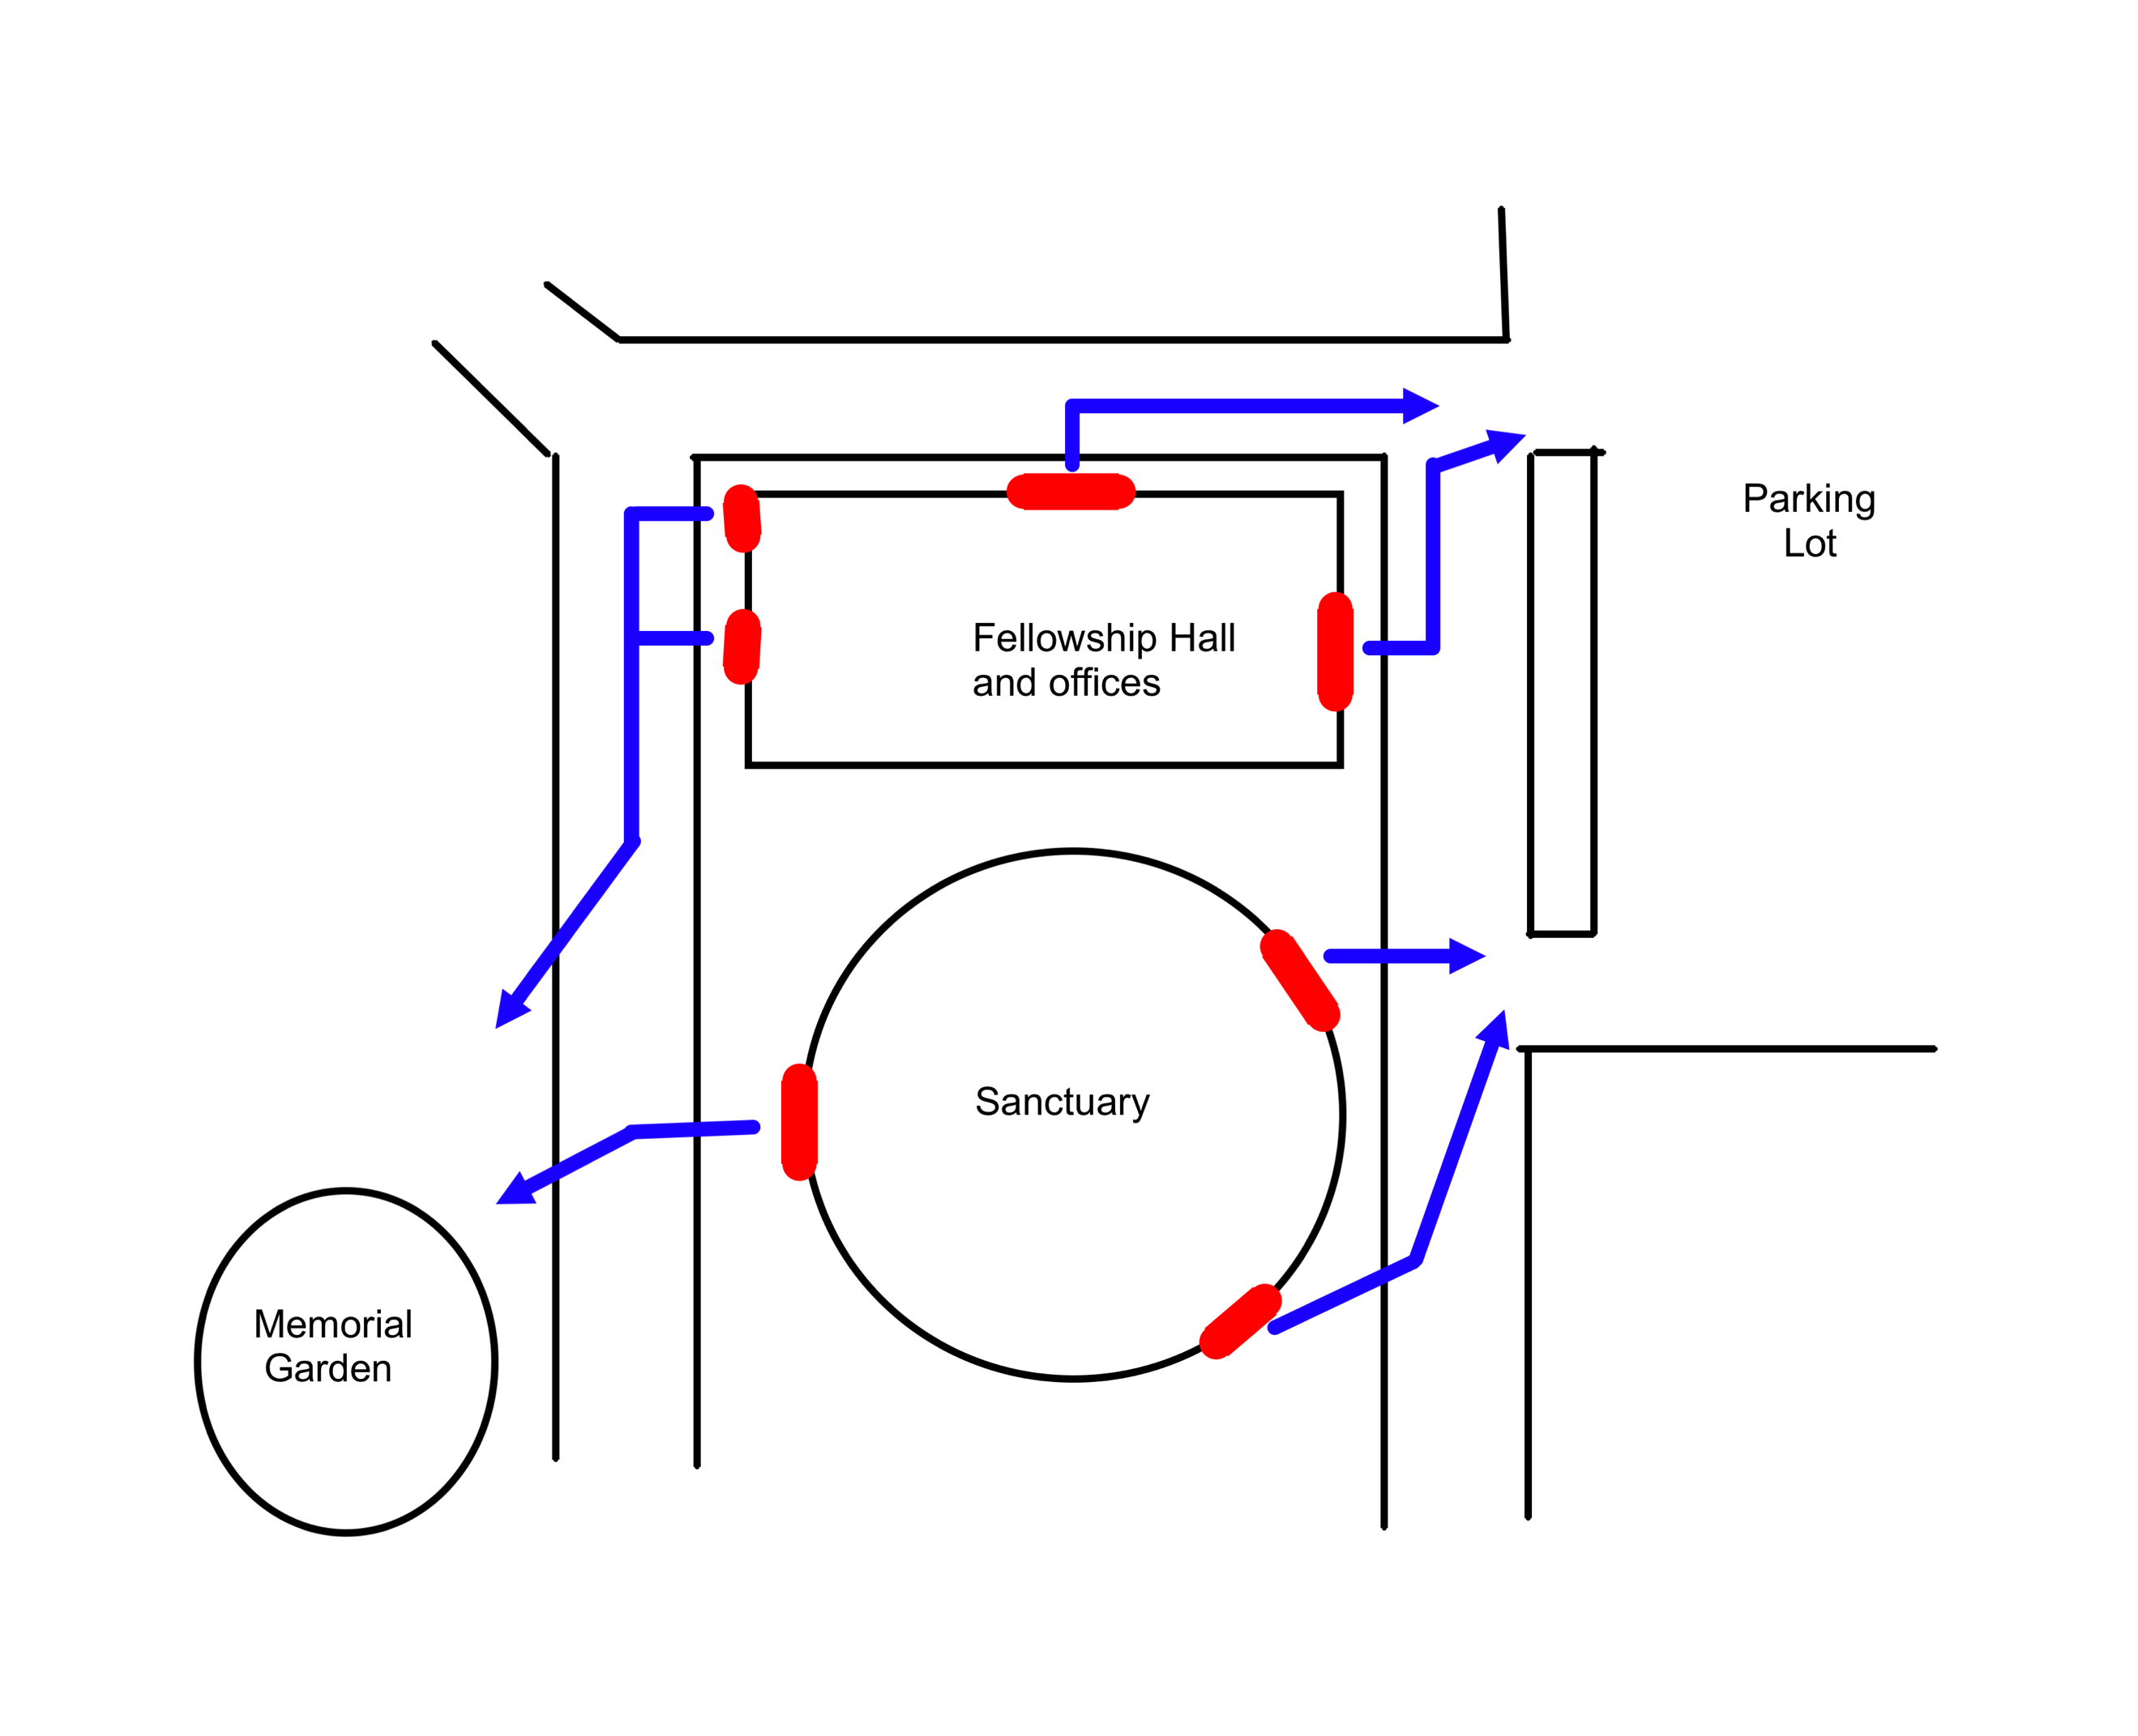

G. DRUG AND ALCOHOL POLICY
It is the policy of the UCR that the possession, purchase, distribution, use and/or abuse of any drugs, alcohol, or paraphernalia, and/or being under the influence of illegal drugs or alcohol is prohibited because it is illegal, antithetical to the UCR’s value system, and extremely dangerous and unhealthy for children and youth. All volunteers, children, and youth participating in UCR activities are expected to support and adhere to this policy and value system.
Drugs shall include, but shall not be limited to, any medicinal preparation (prescription and non-prescription) and any controlled substance whose possession, sale, distribution, use or consumption is illegal under state and/or federal law.
Paraphenalia is defined as any object or item used or designed to be used in the consumption, sale, or distribution of drugs and/or alcohol.
The parents of any child or youth found to be in violation of this drug and alcohol policy, whether on Church property or on an off-site Church activity, will be immediately notified. The UCR also reserves the right to contact the police or any other law enforcement agency to report any criminal activity and/or suspected criminal activity occurring on its grounds or at Church-sponsored activities that is in violation of this drug and alcohol policy.

NOTE: Church events where alcohol is served to adults is an exception to this policy.

H. AUTOMOBILES
Volunteers may use personal automobiles/vehicles for Church use, but said vehicles are not covered by Church property and casualty insurance.
Drivers must provide proof of insurance and a copy of their driver’s license to the Director of Christian Education, in addition to completing the Employment/Authorized Volunteer Application and Disclosure Form (attached).

I. SMOKING
Smoking is prohibited on the campus of The United Church of Rowayton or at its off-campus activities.

J. SCREENING/BACKGROUND CHECKS
Background checks for those working with children are required every five years.

All volunteers who work with children should be expected to complete a Background Check Authorization Form. [See attached form.]

J. United church of rowayton volunteer acknowledgement oF receipt and acceptance

All individuals having positions involving the supervision or custody of children or youth, e.g. church school teachers; all lay leaders; and all board and committee members whose work can bring them into contact with children and/or youth should complete this form.

I have received my copy of the Volunteer Safety Handbook of The United Church of Rowayton, Inc. My signature indicates that I have read, understood, and accepted its provisions.

- If you send this page in an email to billsarr@ucrowayton.org, type your name as an e-signature in this gray space:
and type the date in this space:

- If you print out this page, please complete the following and submit it to the church office:

___________________________________________________________
Volunteer’s Name (print)

___________________________________________________________
Volunteer’s Signature

___________________________________________________________
Date

K. BACKGROUND CHECK AUTHORIZATION

Volunteers in positions involving the supervision or custody of children or youth, e.g. church school and Anchors teachers, infant and toddler care providers, etc., must complete this screening form. Background checks are required every five years.

If you prefer to type your responses, enter them in the text boxes and email this form to clerk@ucrowayton.org.

If you prefer to write your responses, print out the completed form and submit it to the church office.

A. Personal Information

Last Name:

First Name: Middle Name:

Maiden Name:

Date of Birth (xx/xx/xxxx):

Social Security Number (xxx-xx-xxxx):

Home/Mobile Phone Number (xxx-xxx-xxxx):

Email address:

Present address:
Street

City State Zip

How long have you been at this address?

Current Driver’s License

State: Number:

B. Previous Experience
My previous experience in the past five years (paid or volunteer) related to the ministry I am seeking includes:

Agency Name:

Address:

Contact Person: Phone:

Relevant Work:

Agency Name:

Address:

Contact Person: Phone:

Relevant Work:

B. Background Information

I have never been found guilty, pled guilty or no contest, to a criminal charge:
True Not True

If not true, give a short explanation of the charge, indicating the date, nature, and place of the incident leading to the charge; where the charge was filed; and the precise disposition of the case:

Do you have charges (pending) against you for any crime?
Yes No
If yes, please provide a brief explanation.

No civil lawsuit alleging actual or attempted sexual discrimination, harassment, exploitation, or misconduct; physical abuse; child abuse; or financial misconduct has ever resulted in a judgment being entered against me, been settled out of court, or been dismissed because the statute of limitations has expired.
True Not True

If not true, give a short explanation of the lawsuit, indicating the date, nature, and place of the incident leading to the lawsuit; where the lawsuit was filed; and the precise disposition of the lawsuit:

I have never terminated my employment, professional credentials, or service in a volunteer position or had my employment, professional credentials, or authorization to hold a volunteer position terminated for reasons relating to allegations or actual or attempted sexual discrimination, harassment, exploitation, or misconduct; physical abuse; or financial misconduct.
True Not True

If not true, give a short explanation, indicating the date of termination; name, address, and telephone number of employer or volunteer supervisor; and the nature of the incident:

With respect to my driving record, I have not had my license suspended or revoked within the last five years due to reckless driving or driving while intoxicated and/or under the influence of a controlled substance.
True Not True

Is there any fact or circumstance involving you or your background that would call into question your being entrusted with the responsibilities of the position for you want to volunteer:
Yes No
If yes, please provide a brief explanation.

The covenants between persons seeking a staff position or sanctioned volunteer positions in the church require honesty, trust, and truthfulness for the health of the church. To that end, I attest that the information set forth in this application is true and complete. I understand that any misrepresentation or omission may be grounds for rejection of consideration for, or termination of, the position I am seeking to fill. I acknowledge that it is my duty in a timely fashion to amend the responses and information I have provided if I come to know that the response or information was incorrect when given or, though accurate when given, the response or information is no longer accurate. Beginning such relationships with an open exchange of relevant information builds the foundation for a continuing and healthy covenant between staff and volunteers and the church they seek to serve. To that end, I authorize The United Church of Rowayton, Inc. and/or its agents to make inquiries regarding all statements I have set forth above. I also authorize all entities, persons, former employers, supervisors, courts, law enforcement, and other public agencies to respond to inquiries concerning me, to supply verification of the statements I have made, and to comment on and state opinions regarding my background and character. To encourage such persons and entities to speak openly and responsibly. I hereby release them from all liability arising from their responses, comments, and statements made in good faith and without malice.

The United Church of Rowayton, Inc.’s hiring and authorized volunteer recruitment process involves the distribution of information regarding applicants with those persons in a position to recruit, secure, and supervise the position I am seeking to fill. To that end, I authorize The United Church of Rowayton, Inc. and its agents to circulate, distribute, and otherwise share information gathered in connection with this application to such persons for these stated purposes. I understand that The United Church of Rowayton, Inc. will share with me information it has gathered about me, if I request it to do so.

- If you send this page in an email to clerk@ucrowayton.org, type your name as an e-signature in this space:
Type the date in this space:
Enter parent’s/guardian’s signature for applicants under 18 in this space:

- If you print out this page, please complete the following:

___________________________________________________________
Volunteer’s Name (print)

___________________________________________________________
Volunteer’s Signature

___________________________________________________________
Date

___________________________________________________________
Parent’s/guardian’s signature for applicants under 18 in this space:

